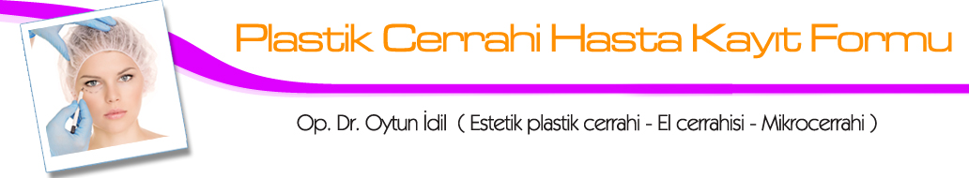
1) Name-surname :

2) Passport no::

3) Date of birth :

4) Occupation :

5) Your marital status (married/single/divorced):

6) GSM number:

7) Address :

8) E-mail:

9) Your request:

10) Do you have a serious illness in your family (mother, father, heart disease, diabetes, etc..):

11) Have you recently tested for Covid-19?

12) How many pregnancies have you had (if you are a woman)?

13) Please write if you have a serious illness or surgery that you have or have had in the past (hypertension, heart disease, rhinoplasty, etc.):

14) Do you smoke, how much?

15) Do you have a known drug allergy?

16) Do you have a medication that you use regularly?

Date and signature:

Op. Dr. Oytun İdil (Estetik plastik ve rekonstrüktif cerrahi uzmanı)
Rumeli cad. Müşerref apt. No:3 Kat:1 Daire:1 Nişantaşı – İstanbul
GSM: +90 533 569 06 49 / +90 505 296 55 69 E-mail: oytunmd@gmail.com
www.calfaugmentation.net – www.idilpenissurgery.com – www.oytunidil.com

